Business Unit
Mobile Failures Report
ASAP 7.0.2 – JAMU66

Week 36
September 03rd to September 09th, 2018

September 10th, 2018

Contents

1 Percentages for all mobile activations, changes and deactivations Anguilla 4
2 Percentages for all mobile activations, changes and deactivations Antigua 5
3 Percentages for all mobile activations, changes and deactivations Barbados 6
4 Percentages for all mobile activations, changes and deactivations British Virgin Islands 7
5 Percentages for all mobile activations, changes and deactivations Cayman 8
6 Percentages for all mobile activations, changes and deactivations Dominica 9
7 Percentages for all mobile activations, changes and deactivations Grenada 10
8 Percentages for all mobile activations, changes and deactivations Jamaica 11
9 Percentages for all mobile activations, changes and deactivations Monserrat 12
10 Percentages for all mobile activations, changes and deactivations Saint Vincent 13
11 Percentages for all mobile activations, changes and deactivations Turks and Caicos 14
12 Percentages for all mobile activations, changes and deactivations Santa Lucia 15
13 Percentages for all mobile activations, changes and deactivations Saint Kitts and Nevis 16
14 Top 5 failure issues Anguilla 17
15 Top 5 failure issues Antigua 17
16 Top 5 failure issues Barbados 17
17 Top 5 failure issues British Virgin Islands 18
18 Top 5 failure issues Cayman 18
19 Top 5 failure issues Dominica 19
20 Top 5 failure issues Grenada 19
21 Top 5 failure issues Jamaica 19
22 Top 5 failure issues Monserrat 20
23 Top 5 failure issues Saint Vincent 20
24 Top 5 failure issues Turks and Caicos 20
25 Top 5 failure issues Santa Lucia 21
26 Top 5 failure issues Saint Kitts and Nevis 21
27 Failure numbers Anguilla 22
28 Failure numbers Antigua 22
29 Failure numbers Barbados 24
30 Failure numbers British Virgin Islands 25
31 Failure numbers Cayman 25
32 Failure numbers Dominica 26
33 Failure Numbers Grenada 27
34 Failure numbers Jamaica 27
35 Failure numbers Monserrat 29
36 Failure numbers Saint Vincent 29
37 Failure numbers Turks and Caicos 29
38 Failure numbers Santa Lucia 31
39 Failure numbers Saint Kitts and Nevis 31

Percentages for all mobile activations, changes and deactivations Anguilla

 | TOTAL | COMPLETE | FAILED | % Total | % COMPLETE | % FAILED
ACTIVATE | 67 | 67 | 0 | 100% | 100% | 0%
DEACTIVATE | 0 | 0 | 0 | 0% | 100% | 0%
MODIFY | 0 | 0 | 0 | 0% | 100% | 0%

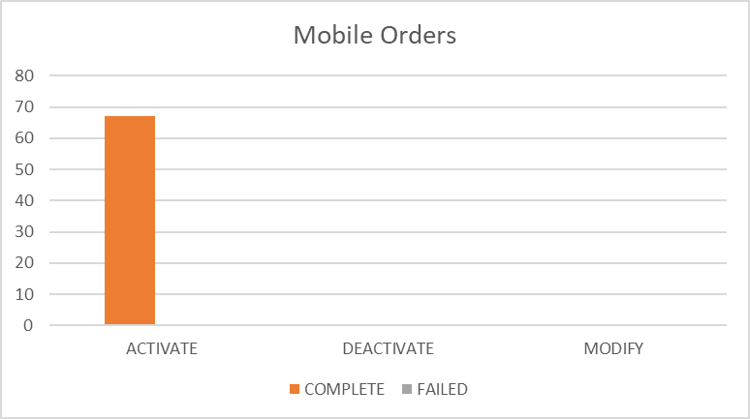

Percentages for all mobile activations, changes and deactivations Antigua

 | TOTAL | COMPLETE | FAILED | % Total | % COMPLETE | % FAILED
ACTIVATE | 909 | 868 | 41 | 24% | 95% | 5%
DEACTIVATE | 304 | 304 | 0 | 8% | 100% | 0%
MODIFY | 2575 | 2507 | 68 | 68% | 97% | 3%

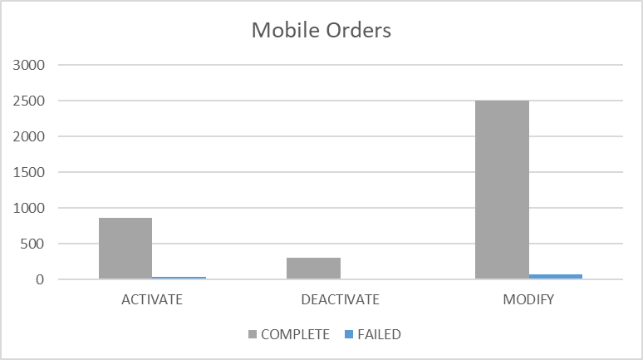

Percentages for all mobile activations, changes and deactivations Barbados

 | TOTAL | COMPLETE | FAILED | % Total | % COMPLETE | % FAILED
ACTIVATE | 33 | 20 | 13 | 2% | 61% | 39%
DEACTIVATE | 772 | 772 | 0 | 38% | 100% | 0%
MODIFY | 1252 | 1214 | 38 | 61% | 97% | 3%

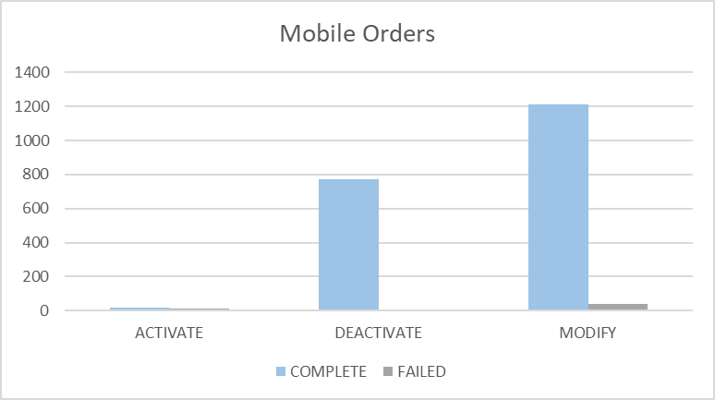

Percentages for all mobile activations, changes and deactivations British Virgin Islands

 | TOTAL | COMPLETE | FAILED | % Total | % COMPLETE | % FAILED
ACTIVATE | 199 | 199 | 0 | 15% | 100% | 0%
DEACTIVATE | 300 | 300 | 0 | 22% | 100% | 0%
MODIFY | 869 | 867 | 2 | 64% | 100% | 0%

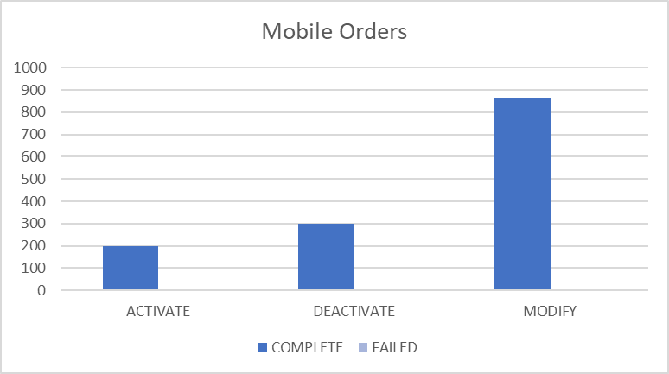

Percentages for all mobile activations, changes and deactivations Cayman

 | TOTAL | COMPLETE | FAILED | % Total | % COMPLETE | % FAILED
ACTIVATE | 633 | 624 | 9 | 24% | 99% | 1%
DEACTIVATE | 295 | 294 | 1 | 11% | 100% | 0%
MODIFY | 1748 | 1702 | 46 | 65% | 97% | 3%

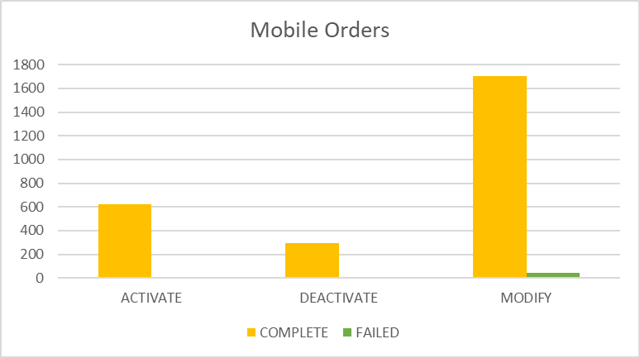

Percentages for all mobile activations, changes and deactivations Dominica

 | TOTAL | COMPLETE | FAILED | % Total | % COMPLETE | % FAILED
ACTIVATE | 112 | 110 | 2 | 6% | 98% | 2%
DEACTIVATE | 380 | 379 | 1 | 21% | 100% | 0%
MODIFY | 1301 | 1279 | 22 | 73% | 98% | 2%

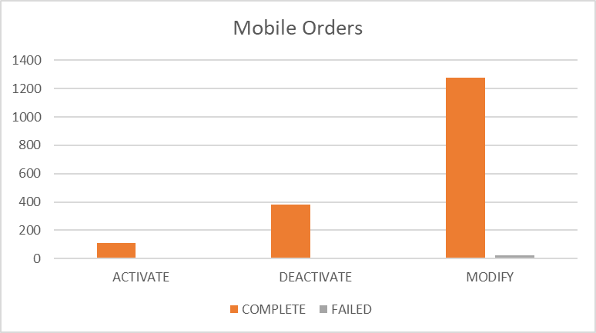

Percentages for all mobile activations, changes and deactivations Grenada

 | TOTAL | COMPLETE | FAILED | % Total | % COMPLETE | % FAILED
ACTIVATE | 114 | 114 | 0 | 9% | 100% | 0%
DEACTIVATE | 366 | 366 | 0 | 29% | 100% | 0%
MODIFY | 770 | 770 | 0 | 62% | 100% | 0%

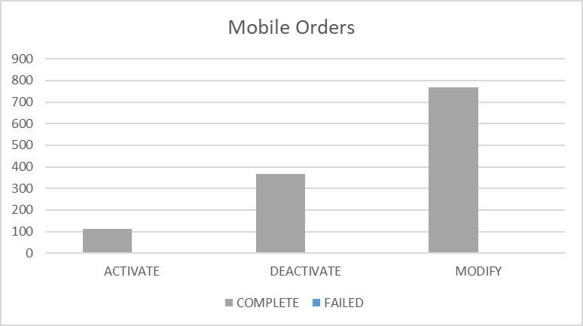

Percentages for all mobile activations, changes and deactivations Jamaica

 | TOTAL | COMPLETE | FAILED | % Total | % COMPLETE | % FAILED
ACTIVATE | 3250 | 3240 | 10 | 12% | 100% | 0%
DEACTIVATE | 5691 | 5687 | 4 | 22% | 100% | 0%
MODIFY | 17524 | 17457 | 67 | 66% | 100% | 0%

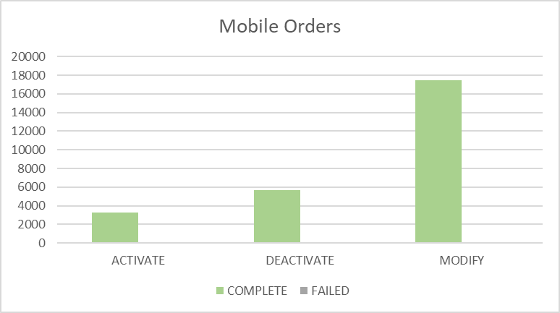

Percentages for all mobile activations, changes and deactivations Monserrat

 | TOTAL | COMPLETE | FAILED | % Total | % COMPLETE | % FAILED
ACTIVATE | 18 | 18 | 0 | 22% | 100% | 0%
DEACTIVATE | 16 | 16 | 0 | 19% | 100% | 0%
MODIFY | 49 | 49 | 0 | 59% | 100% | 0%

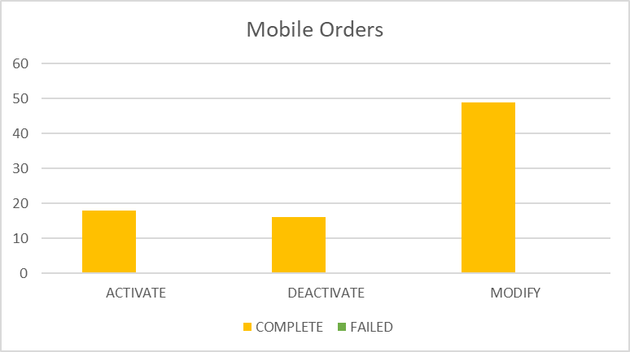

Percentages for all mobile activations, changes and deactivations Saint Vincent

 | TOTAL | COMPLETE | FAILED | % Total | % COMPLETE | % FAILED
ACTIVATE | 207 | 207 | 0 | 15% | 100% | 0%
DEACTIVATE | 420 | 420 | 0 | 29% | 100% | 0%
MODIFY | 798 | 797 | 1 | 56% | 100% | 0%

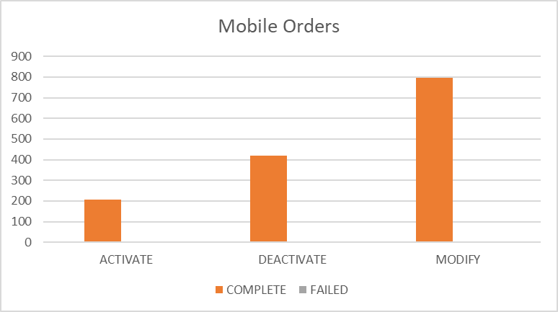

Percentages for all mobile activations, changes and deactivations Turks and Caicos

 | TOTAL | COMPLETE | FAILED | % Total | % COMPLETE | % FAILED
ACTIVATE | 171 | 162 | 9 | 8% | 95% | 5%
DEACTIVATE | 348 | 348 | 0 | 17% | 100% | 0%
MODIFY | 1504 | 1451 | 53 | 74% | 96% | 4%

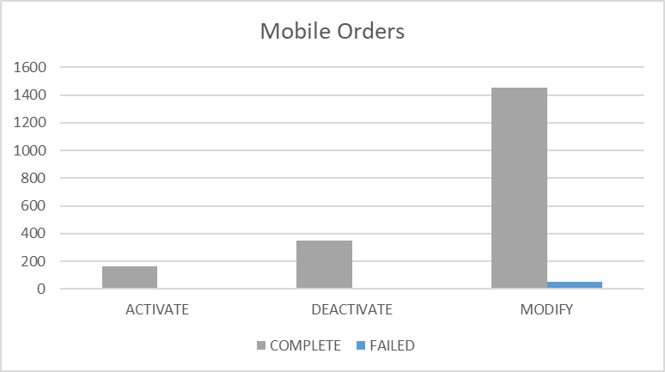

Percentages for all mobile activations, changes and deactivations Santa Lucia

 | TOTAL | COMPLETE | FAILED | % Total | % COMPLETE | % FAILED
ACTIVATE | 599 | 592 | 7 | 18% | 99% | 1%
DEACTIVATE | 378 | 377 | 1 | 11% | 100% | 0%
MODIFY | 2362 | 2348 | 14 | 71% | 99% | 1%

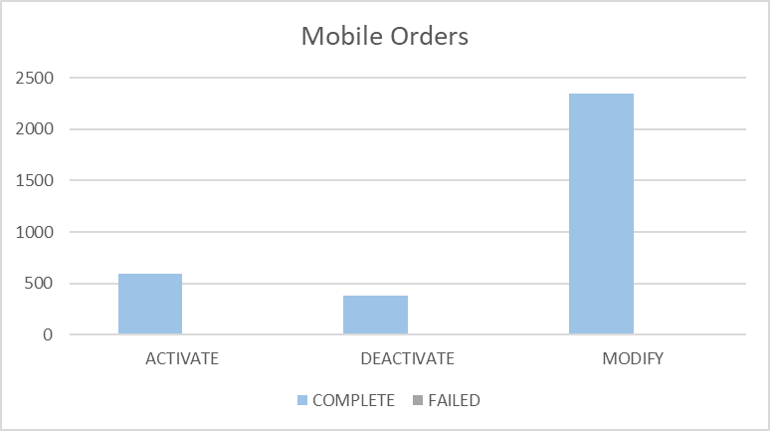

Percentages for all mobile activations, changes and deactivations Saint Kitts and Nevis

 | TOTAL | COMPLETE | FAILED | % Total | % COMPLETE | % FAILED
ACTIVATE | 252 | 250 | 2 | 22% | 99% | 1%
DEACTIVATE | 187 | 187 | 0 | 17% | 100% | 0%
MODIFY | 694 | 690 | 4 | 61% | 99% | 1%

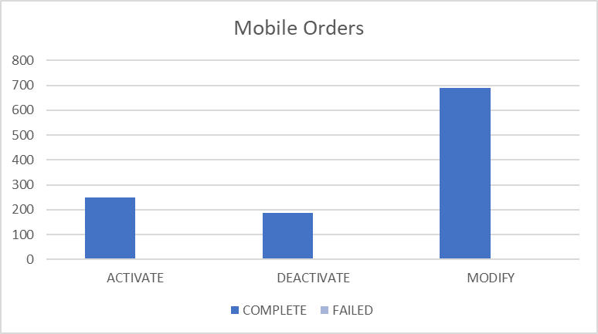

Top 5 failure issues Anguilla

NO ROWS SELECTED

Top 5 failure issues Antigua

AMOUNT | USER EXIT TYPES
50 | EMA_RESP_35101:Missing or invalid parameter.
10 | EMA_MISS_REQ_PARAM:Mandatory parameter is missing from work order
2 | FAIL:No such object
2 | EMA_RESP_35106:The subscriber does not exist.
1 | EMA_RESP_35105:The subscriber already exists.
1 | EMA_NO_UDET_MATCH:No User Defined Exit Type Found
1 | EMA_RESP_13:The Specified IMSI is not defined
1 | EMA_RESP_1:The Specified IMSI is already defined

Top 5 failure issues Barbados

AMOUNT | USER EXIT TYPES
8 | EMA_RESP_13:The Specified IMSI is not defined
7 | EMA_RESP_14:The Specified MSISDN is not defined
6 | EMA_RESP_35101:Missing or invalid parameter.
4 | EMA_RESP_35105:The subscriber already exists.
3 | NGVM_ETTY_DSNT_EXST:The specified Mailbox ID does not exist on the Comverse Voicemail platform.
2 | EMA_RESP_3005:Invalid Argument or out of Range
2 | FAIL:No such object
2 | EMA_MISS_REQ_PARAM:Mandatory parameter is missing from work order
2 | SAPC_EXCEPTION:The NE was denid due to general exception
1 | EMA_RESP_6:Subscriber authentication data not found
1 | EMA_RESP_2:The Specified MSISDN is already defined with a different IMSI

Top 5 failure issues British Virgin Islands

AMOUNT | USER EXIT TYPES
2 | FAIL:No such object

Top 5 failure issues Cayman

AMOUNT | USER EXIT TYPES
20 | EMA_RESP_35106:The subscriber does not exist.
16 | EMA_RESP_35101:Missing or invalid parameter.
3 | EMA_RESP_1:The Specified IMSI is already defined
2 | EMA_RESP_35105:The subscriber already exists.
2 | EMA_RESP_6:Subscriber authentication data not found
1 | FAIL:No such object
1 | NGVM_ETTY_DSNT_EXST:The specified Mailbox ID does not exist on the Comverse Voicemail platform.
1 | MMS10_NO_UDET_MATCH:No User Defined Exit Type Found

Top 5 failure issues Dominica

AMOUNT | USER EXIT TYPES
11 | EMA_RESP_1:The Specified IMSI is already defined
3 | EMA_RESP_35106:The subscriber does not exist.
3 | EMA_RESP_35101:Missing or invalid parameter.
2 | EMA_MISS_REQ_PARAM:Mandatory parameter is missing from work order
1 | EMA_RESP_6:Subscriber authentication data not found
1 | SAPC_PROVCARTEXP:The NE was denid due to provisioning cartridge exception
1 | EMA_RESP_14:The Specified MSISDN is not defined

Top 5 failure issues Grenada

NO ROWS SELECTED

Top 5 failure issues Jamaica

AMOUNT | USER EXIT TYPES
14 | SAPC_EXCEPTION:The NE was denid due to general exception
11 | NGVM_ETTY_DSNT_EXST:The specified Mailbox ID does not exist on the Comverse Voicemail platform.
8 | FAIL:No such object
7 | EMA_RESP_6:Subscriber authentication data not found
7 | SAPC_PROVCARTEXP:The NE was denid due to provisioning cartridge exception
7 | EMA_RESP_1:The Specified IMSI is already defined
5 | EMA_RESP_14:The Specified MSISDN is not defined
2 | EMA_MISS_REQ_PARAM:Mandatory parameter is missing from work order
2 | EMA_RESP_1001:External system communication link failure.
2 | EMA_RESP_2:The Specified MSISDN is already defined with a different IMSI
1 | EMA_RESP_35106:The subscriber does not exist.
1 | FAIL:No User Defined Exit Type Found

Top 5 failure issues Monserrat

NO ROWS SELECTED

Top 5 failure issues Saint Vincent

AMOUNT | USER EXIT TYPES
1 | EMA_RESP_1:The Specified IMSI is already defined

Top 5 failure issues Turks and Caicos

AMOUNT | USER EXIT TYPES
29 | EMA_RESP_35101:Missing or invalid parameter.
14 | EMA_RESP_1:The Specified IMSI is already defined
3 | EMA_RESP_35106:The subscriber does not exist.
2 | EMA_RESP_35105:The subscriber already exists.
2 | FAIL:No such object
1 | SAPC_PROVCARTEXP:The NE was denid due to provisioning cartridge exception
1 | EMA_RESP_13:The Specified IMSI is not defined
1 | NGVM_ETTY_DSNT_EXST:The specified Mailbox ID does not exist on the Comverse Voicemail platform.

Top 5 failure issues Santa Lucia

AMOUNT | USER EXIT TYPES
4 | EMA_RESP_1:The Specified IMSI is already defined
3 | EMA_RESP_35101:Missing or invalid parameter.
2 | EMA_RESP_2:The Specified MSISDN is already defined with a different IMSI
2 | EMA_MISS_REQ_PARAM:Mandatory parameter is missing from work order
1 | NGVM_ETTY_DSNT_EXST:The specified Mailbox ID does not exist on the Comverse Voicemail platform.
1 | EMA_RESP_1001:External system communication link failure.
1 | FAIL:No User Defined Exit Type Found

Top 5 failure issues Saint Kitts and Nevis

AMOUNT | USER EXIT TYPES
2 | EMA_RESP_35105:The subscriber already exists.
2 | EMA_RESP_14:The Specified MSISDN is not defined

Failure numbers Anguilla

NO ROWS SELECTED

Failure numbers Antigua

SRQ_ID | WO_ID | WO_STATUS | MSISDN
1168019 | CIS:BAR:3010059:172.21.64.6:25009:1535977214884 | FAILED | 12687230675
1170366 | CIS:BAR:3010675:172.21.64.6:25009:1535985203140 | FAILED | 12687647153
1170391 | CIS:BAR:3010678:172.21.64.6:25009:1535985288528 | FAILED | 12687710139
1171841 | CIS:BAR:3010744:172.21.64.6:25009:1535989519214 | FAILED | 12687716363
1179297 | CIS:BAR:3011219:172.21.64.6:25009:1536035671333 | FAILED | 12687233262
1179489 | CIS:BAR:3012284:172.21.64.6:25009:1536037414182 | FAILED | 12687702670
1179542 | CIS:BAR:3012602:172.21.64.6:25009:1536037932179 | FAILED | 12687706770
1179575 | CIS:BAR:3012800:172.21.64.6:25009:1536038219076 | FAILED | 12687709915
1181802 | CIS:BAR:3013121:172.21.64.6:25009:1536065711959 | FAILED | 12687827649
1181974 | CIS:BAR:3013149:172.21.64.6:25009:1536067653359 | FAILED | 12687708756
1185680 | CIS:BAR:3013525:172.21.64.6:25009:1536087054956 | FAILED | 12684642633
1191959 | CIS:BAR:3013796:172.21.64.6:25009:1536153643410 | FAILED | 12687280943
1193227 | CIS:BAR:3014513:172.21.64.6:25009:1536162206058 | FAILED | 12687233651
1194979 | CIS:BAR:3014686:172.21.64.6:25009:1536173279477 | FAILED | 12687716712
1194997 | CIS:BAR:3014688:172.21.64.6:25009:1536173322879 | FAILED | 12687642944
1195613 | CIS:BAR:3014787:172.21.64.6:25009:1536176849284 | FAILED | 12687701543
1195946 | CIS:BAR:3014808:172.21.64.6:25009:1536177977855 | FAILED | 12687791993
1200652 | CIS:BAR:3014874:172.21.64.6:25009:1536208323375 | FAILED | 12687237656
1200687 | CIS:BAR:3015084:172.21.64.6:25009:1536208749691 | FAILED | 12687710588
1200711 | CIS:BAR:3015228:172.21.64.6:25009:1536208999236 | FAILED | 12687713535
1200721 | CIS:BAR:3015288:172.21.64.6:25009:1536209108068 | FAILED | 12687716588
1200727 | CIS:BAR:3015318:172.21.64.6:25009:1536209203145 | FAILED | 12687718897
1200732 | CIS:BAR:3015348:172.21.64.6:25009:1536209235502 | FAILED | 12687719083
1200743 | CIS:BAR:3015402:172.21.64.6:25009:1536209356965 | FAILED | 12687720697
1200745 | CIS:BAR:3015414:172.21.64.6:25009:1536209366441 | FAILED | 12687720824
1200750 | CIS:BAR:3015444:172.21.64.6:25009:1536209389976 | FAILED | 12687722143
1200753 | CIS:BAR:3015462:172.21.64.6:25009:1536209404181 | FAILED | 12687722559
1200757 | CIS:BAR:3015486:172.21.64.6:25009:1536209488861 | FAILED | 12687723069
1200759 | CIS:BAR:3015498:172.21.64.6:25009:1536209502002 | FAILED | 12687723286
1200768 | CIS:BAR:3015552:172.21.64.6:25009:1536209602555 | FAILED | 12687724263
1200769 | CIS:BAR:3015558:172.21.64.6:25009:1536209609232 | FAILED | 12687724591
1200773 | CIS:BAR:3015582:172.21.64.6:25009:1536209656686 | FAILED | 12687725255
1200779 | CIS:BAR:3015618:172.21.64.6:25009:1536209696747 | FAILED | 12687726106
1200790 | CIS:BAR:3015684:172.21.64.6:25009:1536209864040 | FAILED | 12687727534
1200792 | CIS:BAR:3015696:172.21.64.6:25009:1536209873521 | FAILED | 12687727627
1200793 | CIS:BAR:3015702:172.21.64.6:25009:1536209878250 | FAILED | 12687727941
1200795 | CIS:BAR:3015714:172.21.64.6:25009:1536209887874 | FAILED | 12687728000
1200796 | CIS:BAR:3015720:172.21.64.6:25009:1536209892731 | FAILED | 12687728243
1200800 | CIS:BAR:3015744:172.21.64.6:25009:1536209911558 | FAILED | 12687729881
1200819 | CIS:BAR:3015852:172.21.64.6:25009:1536210100194 | FAILED | 12687761057
1200830 | CIS:BAR:3015918:172.21.64.6:25009:1536210180929 | FAILED | 12687761072
1200865 | CIS:BAR:3016128:172.21.64.6:25009:1536210522319 | FAILED | 12687761126
1200885 | CIS:BAR:3016254:172.21.64.6:25009:1536210751203 | FAILED | 12687761173
1200992 | CIS:BAR:3016809:172.21.64.6:25009:1536211898024 | FAILED | 12687761335
1201069 | CIS:BAR:3017271:172.21.64.6:25009:1536212818453 | FAILED | 12687761446
1201124 | CIS:BAR:3017601:172.21.64.6:25009:1536213341222 | FAILED | 12687761525
1202676 | CIS:BAR:3018128:172.21.64.6:25009:1536236850609 | FAILED | 12687723289
1202707 | CIS:BAR:3018143:172.21.64.6:25009:1536237423111 | FAILED | 12687723289
1202710 | CIS:BAR:3018146:172.21.64.6:25009:1536237509272 | FAILED | 12687723289
1202770 | CIS:BAR:3018197:172.21.64.6:25009:1536239355951 | FAILED | 12687723289
1202830 | CIS:BAR:3018240:172.21.64.6:25009:1536240354399 | FAILED | 12687721519
1202838 | CIS:BAR:3018242:172.21.64.6:25009:1536240426910 | FAILED | 12687721519
1204594 | CIS:BAR:3019962:172.21.64.6:25009:1536247833250 | FAILED | 12687642332
1204704 | CIS:BAR:3019984:172.21.64.6:25009:1536248332791 | FAILED | 12687642332
1204716 | CIS:BAR:3019996:172.21.64.6:25009:1536248432001 | FAILED | 12687642332
1208239 | CIS:BAR:3020446:172.21.64.6:25009:1536265171389 | FAILED | 12684640045
1212365 | CIS:BAR:3020771:172.21.64.6:25009:1536327503185 | FAILED | 12687893240
1213590 | CIS:BAR:3020928:172.21.64.6:25009:1536336472319 | FAILED | 12687785566
1214772 | CIS:BAR:3021166:172.21.64.6:25009:1536344232394 | FAILED | 12687796869
1214807 | CIS:BAR:3021176:172.21.64.6:25009:1536344442410 | FAILED | 12687796869
1215392 | CIS:BAR:3021264:172.21.64.6:25009:1536347741879 | FAILED | 12684649583
1215732 | CIS:BAR:3021297:172.21.64.6:25009:1536349626522 | FAILED | 12687717381
1216122 | CIS:BAR:3021333:172.21.64.6:25009:1536352187856 | FAILED | 12687840277
1216299 | CIS:BAR:3021348:172.21.64.6:25009:1536352710990 | FAILED | 12687707578
1220588 | CIS:BAR:3021656:172.21.64.6:25009:1536416362163 | FAILED | 12687789609
1220625 | CIS:BAR:3021663:172.21.64.6:25009:1536417112469 | FAILED | 12687723599
1220903 | CIS:BAR:3021703:172.21.64.6:25009:1536421262775 | FAILED | 12687284018
1221196 | CIS:BAR:3021732:172.21.64.6:25009:1536424221111 | FAILED | 12687725797

Failure numbers Barbados

SRQ_ID | WO_ID | WO_STATUS | MSISDN
1169875 | OCA-6968 | FAILED | 12461853255
1169893 | OCA-6971 | FAILED | 12462314357
1173153 | OCA-6981 | FAILED | 12462539945
1173868 | CIS:BAR:23821747:172.21.64.13:25001:1535995560972 | FAILED | 12462348511
1173890 | CIS:BAR:23821750:172.21.64.13:25001:1535995658421 | FAILED | 12462348511
1174933 | CIS:BAR:23821788:172.21.64.13:25001:1536000680120 | FAILED | 12462329474
1174941 | CIS:BAR:23821791:172.21.64.13:25001:1536000740428 | FAILED | 12462329474
1175051 | OCA-6988 | FAILED | 12462539945
1177240 | CIS:BAR:23821867:172.21.64.13:25001:1536014372422 | FAILED | 12462843973
1184066 | CIS:BAR:23822667:172.21.64.13:25001:1536078199716 | FAILED | 12462422413
1185993 | CIS:BAR:23822733:172.21.64.13:25001:1536088877373 | FAILED | 12462489084
1190894 | OCA-7028 | FAILED | 12462337192
1191388 | OCA-7036D | FAILED | 12462317016
1191553 | OCA-7040 | FAILED | 12462317016
1191577 | OCA-7041 | FAILED | 12462317016
1192331 | OCA-7056 | FAILED | 12462329474
1192942 | CIS:BAR:23823264:172.21.64.13:25001:1536160496907 | FAILED | 12462507299
1194460 | CIS:BAR:23823335:172.21.64.13:25001:1536169593926 | FAILED | 12462310454
1203243 | CIS:BAR:23823994:172.21.64.13:25001:1536240945578 | FAILED | 12462438631
1203563 | CIS:BAR:23824013:172.21.64.13:25001:1536243822378 | FAILED | 12462328016
1203572 | CIS:BAR:23824018:172.21.64.13:25001:1536243880286 | FAILED | 12462328016
1203847 | CIS:BAR:23824025:172.21.64.13:25001:1536244550661 | FAILED | 12462426204
1204345 | CIS:BAR:23824043:172.21.64.13:25001:1536246204432 | FAILED | 12462403773
1204617 | CIS:BAR:23824070:172.21.64.13:25001:1536247862575 | FAILED | 12462351741
1204891 | CIS:BAR:23824099:172.21.64.13:25001:1536249473810 | FAILED | 12462363092
1205251 | OCA-7080 | FAILED | 12462438631
1205327 | OCA-7083 | FAILED | 12462310454
1205497 | OCA-7084 | FAILED | 12462310454
1206705 | OCA-7096 | FAILED | #########
1212061 | OCA-7098 | FAILED | 12462438631
1212074 | OCA-7101 | FAILED | 12462438631
1213446 | CIS:BAR:23824899:172.21.64.13:25001:1536335836458 | FAILED | 12462350332
1213914 | CIS:BAR:23824911:172.21.64.13:25001:1536338180010 | FAILED | 12462311584
1214305 | OCA-7116 | FAILED | 12462324655
1217109 | OCA-7126 | FAILED | 12462539945
1217166 | OCA-7132 | FAILED | 12462539945
1225008 | CIS:BAR:23826331:172.21.64.13:25001:1536495408426 | FAILED | 12462304998
1225010 | CIS:BAR:23826334:172.21.64.13:25001:1536495468080 | FAILED | 12462304998

Failure numbers British Virgin Islands

SRQ_ID | WO_ID | WO_STATUS | MSISDN
1220929 | CIS:BAR:2906659:172.21.64.3:25002:1536421512332 | FAILED | 12845447742
1223551 | CIS:BAR:2906760:172.21.64.3:25002:1536459471411 | FAILED | 12845427696

Failure numbers Cayman

SRQ_ID | WO_ID | WO_STATUS | MSISDN
1171312 | CIS:CAY:6119125:172.21.64.16:25003:1535988737243 | FAILED | 13455165858
1173073 | CIS:CAY:6119214:172.21.64.16:25003:1535991696614 | FAILED | 13459162707
1173087 | CIS:CAY:6119216:172.21.64.16:25003:1535991761857 | FAILED | 13459162707
1173147 | CIS:CAY:6119220:172.21.64.16:25003:1535992147486 | FAILED | 13459162707
1176944 | CIS:JAM:6119838:172.21.64.16:25003:1536012768359 | FAILED | 13459161962
1177004 | CIS:CAY:6119844:172.21.64.16:25003:1536013198285 | FAILED | 13459168183
1177186 | CIS:CAY:6119860:172.21.64.16:25003:1536014159410 | FAILED | 13459255547
1184396 | CIS:CAY:6120624:172.21.64.16:25003:1536080071334 | FAILED | 13459251869
1184629 | CIS:CAY:6120697:172.21.64.16:25003:1536081433606 | FAILED | 13453213259
1205232 | CIS:CAY:6122553:172.21.64.16:25003:1536250785614 | FAILED | 13459164247
1205276 | CIS:CAY:6122595:172.21.64.16:25003:1536250984456 | FAILED | 13459163235
1205498 | CIS:CAY:6122647:172.21.64.16:25003:1536251849414 | FAILED | 13459160848
1205672 | CIS:CAY:6122973:172.21.64.16:25003:1536252559087 | FAILED | 13459163363
1205714 | CIS:CAY:6123110:172.21.64.16:25003:1536252726789 | FAILED | 13459257919
1205754 | CIS:CAY:6123277:172.21.64.16:25003:1536252789611 | FAILED | 13459385540
1205871 | CIS:CAY:6123782:172.21.64.16:25003:1536252950193 | FAILED | 13459255553
1205914 | CIS:CAY:6123945:172.21.64.16:25003:1536252999844 | FAILED | 13459389124
1206034 | CIS:CAY:6124158:172.21.64.16:25003:1536253085042 | FAILED | 13459297477
1206732 | CIS:CAY:6124417:172.21.64.16:25003:1536255408506 | FAILED | 13459274889
1206768 | CIS:CAY:6124547:172.21.64.16:25003:1536255441348 | FAILED | 13459384952
1206973 | CIS:CAY:6124644:172.21.64.16:25003:1536256785276 | FAILED | 13459384952
1207427 | CIS:CAY:6124725:172.21.64.16:25003:1536259723911 | FAILED | 13459167310
1207522 | CIS:CAY:6124745:172.21.64.16:25003:1536260365662 | FAILED | 13459264626
1207561 | CIS:CAY:6124750:172.21.64.16:25003:1536260555394 | FAILED | 13459264626
1208491 | CIS:CAY:6124876:172.21.64.16:25003:1536266336400 | FAILED | 13459385540
1209496 | CIS:CAY:6125083:172.21.64.16:25003:1536274509288 | FAILED | 13459261917
1209500 | CIS:CAY:6125085:172.21.64.16:25003:1536274592349 | FAILED | 13459261917
1210265 | CIS:CAY:6125112:172.21.64.16:25003:1536278976884 | FAILED | 13459252479
1212749 | CIS:CAY:6125323:172.21.64.16:25003:1536330908790 | FAILED | 13459267428
1212783 | CIS:CAY:6125327:172.21.64.16:25003:1536331135162 | FAILED | 13459267428
1214213 | CIS:CAY:6125589:172.21.64.16:25003:1536340212228 | FAILED | 13459160977
1214511 | CIS:CAY:6125656:172.21.64.16:25003:1536342017048 | FAILED | 13459257478
1214523 | CIS:CAY:6125660:172.21.64.16:25003:1536342119328 | FAILED | 13459257478
1215944 | CIS:CAY:6125817:172.21.64.16:25003:1536350595485 | FAILED | 13459257527
1216043 | CIS:CAY:6125833:172.21.64.16:25003:1536351583843 | FAILED | 13459164247
1216921 | CIS:CAY:6125952:172.21.64.16:25003:1536356961290 | FAILED | 13459260524
1217616 | CIS:CAY:6125992:172.21.64.16:25003:1536362275873 | FAILED | 13459252479
1217625 | CIS:CAY:6125995:172.21.64.16:25003:1536362448547 | FAILED | 13459252479
1218169 | CIS:CAY:6126025:172.21.64.16:25003:1536367387515 | FAILED | 13459274889
1218493 | CIS:CAY:6126251:172.21.64.16:25003:1536384773816 | FAILED | 13459288459
1218502 | CIS:CAY:6126305:172.21.64.16:25003:1536384816085 | FAILED | 13459288476
1218506 | CIS:CAY:6126329:172.21.64.16:25003:1536384832424 | FAILED | 13459288482
1218509 | CIS:CAY:6126347:172.21.64.16:25003:1536384844744 | FAILED | 13459288486
1218567 | CIS:CAY:6126695:172.21.64.16:25003:1536385109047 | FAILED | 13459288619
1218642 | CIS:CAY:6127139:172.21.64.16:25003:1536385418892 | FAILED | 13459288781
1223840 | CIS:CAY:6129560:172.21.64.16:25003:1536485043467 | FAILED | 13459296937

Failure numbers Dominica

SRQ_ID | WO_ID | WO_STATUS | MSISDN
1182662 | CIS:BAR:4297166:172.21.64.4:25008:1536071734317 | FAILED | 17672777599
1182943 | CIS:BAR:4297218:172.21.64.4:25008:1536073805750 | FAILED | 17672350884
1182943 | CIS:BAR:4297218:172.21.64.4:25008:1536073805750 | FAILED | 17672850884
1193416 | CIS:BAR:4298011:172.21.64.4:25008:1536163197435 | FAILED | 17672650780
1213062 | CIS:BAR:4302868:172.21.64.4:25008:1536333098869 | FAILED | 17672773901
1213087 | CIS:BAR:4302870:172.21.64.4:25008:1536333189762 | FAILED | 17672773901
1214831 | CIS:BAR:4303220:172.21.64.4:25008:1536344737603 | FAILED | 17672353667
1214842 | CIS:BAR:4303225:172.21.64.4:25008:1536344822984 | FAILED | 17672353667
1214850 | CIS:BAR:4303230:172.21.64.4:25008:1536344936245 | FAILED | 17672353667
1215340 | CIS:BAR:4303406:172.21.64.4:25008:1536347395724 | FAILED | 17672353667
1215341 | CIS:BAR:4303411:172.21.64.4:25008:1536347404539 | FAILED | 17672353667
1215354 | CIS:BAR:4303418:172.21.64.4:25008:1536347471031 | FAILED | 17672353667
1215364 | CIS:BAR:4303429:172.21.64.4:25008:1536347552520 | FAILED | 17672353667
1215370 | CIS:BAR:4303431:172.21.64.4:25008:1536347610957 | FAILED | 17672353667
1215388 | CIS:BAR:4303438:172.21.64.4:25008:1536347681421 | FAILED | 17672353667
1215400 | CIS:BAR:4303451:172.21.64.4:25008:1536347790233 | FAILED | 17672353667
1215454 | CIS:BAR:4303484:172.21.64.4:25008:1536348018153 | FAILED | 17672353667
1215468 | CIS:BAR:4303486:172.21.64.4:25008:1536348075819 | FAILED | 17672353667
1215493 | CIS:BAR:4303534:172.21.64.4:25008:1536348241988 | FAILED | 17672353667
1215513 | CIS:BAR:4303539:172.21.64.4:25008:1536348387760 | FAILED | 17672353667
1215556 | CIS:BAR:4303593:172.21.64.4:25008:1536348598722 | FAILED | 17672353667
1215726 | CIS:BAR:4303656:172.21.64.4:25008:1536349557424 | FAILED | 17672353667
1220393 | CIS:BAR:4304094:172.21.64.4:25008:1536411509883 | FAILED | 17672751207

Failure Numbers Grenada

NO ROWS SELECTED

Failure numbers Jamaica

SRQ_ID | WO_ID | WO_STATUS | MSISDN
1172709 | CIS:JAM:186634826:172.21.64.17:25007:1535991230527 | FAILED | 18764289161
1173803 | CIS:JAM:186637074:172.21.64.17:25007:1535995116123 | FAILED | 18769976493
1173910 | CIS:JAM:186637375:172.21.64.17:25007:1535995713529 | FAILED | 18762229826
1175345 | CIS:JAM:186641359:172.21.64.17:25007:1536003079459 | FAILED | 18765386154
1182157 | CIS:JAM:186727149:172.21.64.17:25007:1536069827795 | FAILED | 18764707847
1182523 | CIS:JAM:186727845:172.21.64.17:25007:1536071274775 | FAILED | 18765279973
1185033 | CIS:JAM:186733320:172.21.64.17:25007:1536083119291 | FAILED | 18768194802
1185337 | CIS:JAM:186734176:172.21.64.17:25007:1536085588633 | FAILED | 18768344103
1185430 | CIS:JAM:186734504:172.21.64.17:25007:1536085932391 | FAILED | 18768229932
1185640 | CIS:JAM:186735004:172.21.64.17:25007:1536086743421 | FAILED | 18769979074
1185682 | CIS:JAM:186735127:172.21.64.17:25007:1536087058271 | FAILED | 18769198107
1185690 | CIS:JAM:186735146:172.21.64.17:25007:1536087130057 | FAILED | 18768321549
1186147 | CIS:JAM:186736312:172.21.64.17:25007:1536089654321 | FAILED | 18768178713
1186220 | CIS:JAM:186736522:172.21.64.17:25007:1536090128069 | FAILED | 18769976493
1186563 | CIS:JAM:186737515:172.21.64.17:25007:1536091619019 | FAILED | 18765510799
1186596 | CIS:JAM:186737626:172.21.64.17:25007:1536091756041 | FAILED | 18765510799
1187068 | CIS:JAM:186739371:172.21.64.17:25007:1536094078511 | FAILED | 18769979794
1187940 | CIS:JAM:186742181:172.21.64.17:25007:1536098704486 | FAILED | 18768109176
1193483 | CIS:JAM:186770469:172.21.64.17:25007:1536163507570 | FAILED | 18765841575
1193490 | CIS:JAM:186770487:172.21.64.17:25007:1536163550490 | FAILED | 18765841575
1194442 | CIS:JAM:186773845:172.21.64.17:25007:1536169435311 | FAILED | 18768203476
1194924 | CIS:JAM:186775320:172.21.64.17:25007:1536172936581 | FAILED | 18765401199
1195285 | CIS:JAM:186776348:172.21.64.17:25007:1536174630655 | FAILED | 18768333908
1195574 | CIS:JAM:186777212:172.21.64.17:25007:1536176510404 | FAILED | 18763222714
1196712 | CIS:JAM:186780624:172.21.64.17:25007:1536181755213 | FAILED | 18767799147
1196728 | CIS:JAM:186780644:172.21.64.17:25007:1536181847921 | FAILED | 18767799147
1197018 | CIS:JAM:186781470:172.21.64.17:25007:1536184212322 | FAILED | 18767799147
1197804 | CIS:JAM:186785752:172.21.64.17:25007:1536187945829 | FAILED | 18763190720
1197818 | CIS:JAM:186785822:172.21.64.17:25007:1536187967396 | FAILED | 18763141315
1198165 | CIS:JAM:186786540:172.21.64.17:25007:1536190408048 | FAILED | 18768038913
1203436 | CIS:JAM:186807472:172.21.64.17:25007:1536242994154 | FAILED | 18768216965
1203779 | CIS:JAM:186808526:172.21.64.17:25007:1536244231388 | FAILED | 18768236987
1203828 | CIS:JAM:186808604:172.21.64.17:25007:1536244290875 | FAILED | 18768038913
1203889 | CIS:JAM:186808730:172.21.64.17:25007:1536244693759 | FAILED | 18768038913
1203912 | CIS:JAM:186808807:172.21.64.17:25007:1536244838973 | FAILED | 18768038913
1203991 | CIS:JAM:186808820:172.21.64.17:25007:1536244966716 | FAILED | 18768038913
1204671 | CIS:JAM:186810130:172.21.64.17:25007:1536248258585 | FAILED | 18765090092
1204725 | CIS:JAM:186810200:172.21.64.17:25007:1536248503173 | FAILED | 18768038913
1205673 | CIS:JAM:186812346:172.21.64.17:25007:1536252577166 | FAILED | 18763170000
1205917 | CIS:JAM:186812468:172.21.64.17:25007:1536253001657 | FAILED | 18768339631
1208136 | CIS:JAM:186817899:172.21.64.17:25007:1536264488728 | FAILED | 18769193064
1209811 | CIS:JAM:186823946:172.21.64.17:25007:1536275957122 | FAILED | 18769972627
1210423 | CIS:JAM:186826362:172.21.64.17:25007:1536283956412 | FAILED | 18764770408
1212005 | CIS:JAM:186872924:172.21.64.17:25007:1536317703409 | FAILED | 18765841575
1212210 | CIS:JAM:186873320:172.21.64.17:25007:1536325494971 | FAILED | 18769904891
1212262 | CIS:JAM:186873798:172.21.64.17:25007:1536326483261 | FAILED | 18765841575
1212272 | CIS:JAM:186873813:172.21.64.17:25007:1536326685606 | FAILED | 18765841575
1212282 | CIS:JAM:186873821:172.21.64.17:25007:1536326802538 | FAILED | 18768180614
1212329 | CIS:JAM:186873905:172.21.64.17:25007:1536327236440 | FAILED | 18768232551
1213057 | CIS:JAM:177172171:172.21.64.99:25007:1536333074990 | FAILED | 18766000122
1213214 | CIS:JAM:177172183:172.21.64.99:25007:1536334109765 | FAILED | 18766000122
1213290 | CIS:JAM:177172185:172.21.64.99:25007:1536334531834 | FAILED | 18766000122
1215154 | CIS:JAM:186881017:172.21.64.17:25007:1536345931305 | FAILED | 18768223544
1215270 | CIS:JAM:186881306:172.21.64.17:25007:1536346859278 | FAILED | 18768223544
1215289 | CIS:JAM:186881347:172.21.64.17:25007:1536347030441 | FAILED | 18768223544
1216337 | CIS:JAM:186884188:172.21.64.17:25007:1536352982228 | FAILED | 18763223283
1216644 | CIS:JAM:186885358:172.21.64.17:25007:1536355258020 | FAILED | 18768322822
1216644 | CIS:JAM:186885358:172.21.64.17:25007:1536355258020 | FAILED | 18769974760
1217147 | CIS:JAM:186886809:172.21.64.17:25007:1536358362924 | FAILED | 18768322822
1217147 | CIS:JAM:186886809:172.21.64.17:25007:1536358362924 | FAILED | 18769974760
1217185 | CIS:JAM:186886943:172.21.64.17:25007:1536358880888 | FAILED | 18768322822
1217185 | CIS:JAM:186886943:172.21.64.17:25007:1536358880888 | FAILED | 18769974760
1217393 | CIS:JAM:186887526:172.21.64.17:25007:1536360344864 | FAILED | 18768322822
1217393 | CIS:JAM:186887526:172.21.64.17:25007:1536360344864 | FAILED | 18769974760
1217441 | CIS:JAM:186887647:172.21.64.17:25007:1536360865698 | FAILED | 18768229162
1217456 | CIS:JAM:186887686:172.21.64.17:25007:1536361024220 | FAILED | 18768229162
1217577 | CIS:JAM:186887974:172.21.64.17:25007:1536361792385 | FAILED | 18768229162
1220436 | CIS:JAM:186897615:172.21.64.17:25007:1536412740535 | FAILED | 18763206917
1220442 | CIS:JAM:186897621:172.21.64.17:25007:1536412852805 | FAILED | 18763206917
1225062 | CIS:JAM:186967092:172.21.64.17:25007:1536500543691 | FAILED | 18768025145
1225358 | CIS:JAM:186968073:172.21.64.17:25007:1536529639850 | FAILED | 18768168006

Failure numbers Monserrat

NO ROWS SELECTED

Failure numbers Saint Vincent

SRQ_ID | WO_ID | WO_STATUS | MSISDN
1191871 | CIS:BAR:3468244:172.21.64.8:25012:1536151907904 | FAILED | 17844558734

Failure numbers Turks and Caicos

SRQ_ID | WO_ID | WO_STATUS | MSISDN
1168173 | CIS:BAR:2494039:172.21.64.5:25007:1535977324167 | FAILED | 16492478875
1169866 | CIS:BAR:2494805:172.21.64.5:25007:1535983772120 | FAILED | 16492418882
1170748 | CIS:BAR:2495448:172.21.64.5:25007:1535986803288 | FAILED | 16492320846
1171074 | CIS:BAR:2495872:172.21.64.5:25007:1535987888281 | FAILED | 16492468200
1172185 | CIS:BAR:2496027:172.21.64.5:25007:1535990323239 | FAILED | 16494310052
1172192 | CIS:BAR:2496030:172.21.64.5:25007:1535990348947 | FAILED | 16492321276
1172273 | CIS:BAR:2496032:172.21.64.5:25007:1535990510142 | FAILED | 16492321276
1172340 | CIS:BAR:2496060:172.21.64.5:25007:1535990786513 | FAILED | 16492321276
1173668 | CIS:BAR:2499414:172.21.64.5:25007:1535994413494 | FAILED | 16492435547
1173691 | CIS:BAR:2499426:172.21.64.5:25007:1535994539615 | FAILED | 16492435547
1173763 | CIS:BAR:2499446:172.21.64.5:25007:1535995019200 | FAILED | 16492321248
1173765 | CIS:BAR:2499449:172.21.64.5:25007:1535995054091 | FAILED | 16492321248
1174478 | CIS:BAR:2499583:172.21.64.5:25007:1535997969700 | FAILED | 16492417923
1174826 | CIS:BAR:2499732:172.21.64.5:25007:1536000132790 | FAILED | 16492473797
1175053 | CIS:BAR:2499796:172.21.64.5:25007:1536001341548 | FAILED | 16492418410
1175218 | CIS:BAR:2499837:172.21.64.5:25007:1536002247791 | FAILED | 16494326969
1182916 | CIS:BAR:2500629:172.21.64.5:25007:1536073627842 | FAILED | 16492424215
1183823 | CIS:BAR:2500742:172.21.64.5:25007:1536076973822 | FAILED | 16492475403
1185869 | CIS:BAR:2500988:172.21.64.5:25007:1536088117814 | FAILED | 16494312971
1188179 | CIS:BAR:2501200:172.21.64.5:25007:1536099740265 | FAILED | 16492414054
1191927 | CIS:BAR:2501324:172.21.64.5:25007:1536152954900 | FAILED | 16492429419
1192122 | CIS:BAR:2501561:172.21.64.5:25007:1536154940849 | FAILED | 16492479532
1192127 | CIS:BAR:2501565:172.21.64.5:25007:1536155008753 | FAILED | 16492479532
1192511 | CIS:BAR:2501634:172.21.64.5:25007:1536157828911 | FAILED | 16494414145
1192517 | CIS:BAR:2501638:172.21.64.5:25007:1536157877946 | FAILED | 16494414145
1193224 | CIS:BAR:2501710:172.21.64.5:25007:1536162186566 | FAILED | 16492323754
1193236 | CIS:BAR:2501718:172.21.64.5:25007:1536162304987 | FAILED | 16492323777
1193240 | CIS:BAR:2501720:172.21.64.5:25007:1536162328070 | FAILED | 16492323754
1193249 | CIS:BAR:2501721:172.21.64.5:25007:1536162356979 | FAILED | 16492323777
1194112 | CIS:BAR:2501811:172.21.64.5:25007:1536167174621 | FAILED | 16494320090
1194240 | CIS:BAR:2501818:172.21.64.5:25007:1536168041833 | FAILED | 16494320090
1194247 | CIS:BAR:2501820:172.21.64.5:25007:1536168072894 | FAILED | 16492414054
1196241 | CIS:BAR:2502018:172.21.64.5:25007:1536178751125 | FAILED | 16492453672
1196255 | CIS:BAR:2502020:172.21.64.5:25007:1536178807804 | FAILED | 16492453672
1196813 | CIS:BAR:2502038:172.21.64.5:25007:1536182509159 | FAILED | 16492314464
1201394 | CIS:BAR:2502136:172.21.64.5:25007:1536225803339 | FAILED | 16494414145
1201486 | CIS:BAR:2502152:172.21.64.5:25007:1536225869481 | FAILED | 16494414145
1201896 | CIS:BAR:2502300:172.21.64.5:25007:1536226628474 | FAILED | 16494414145
1203253 | CIS:BAR:2502392:172.21.64.5:25007:1536240964743 | FAILED | 16492423562
1203380 | CIS:BAR:2502415:172.21.64.5:25007:1536242480780 | FAILED | 16492446948
1206209 | CIS:NOR:2502560:172.21.64.5:25007:1536253389402 | FAILED | 16494336011
1206795 | CIS:BAR:2502722:172.21.64.5:25007:1536255521274 | FAILED | 16492414866
1207990 | CIS:BAR:2502914:172.21.64.5:25007:1536263821830 | FAILED | 16492432019
1208020 | CIS:BAR:2502916:172.21.64.5:25007:1536264020932 | FAILED | 16492437979
1208109 | CIS:BAR:2502919:172.21.64.5:25007:1536264296185 | FAILED | 16492434036
1208120 | CIS:BAR:2502921:172.21.64.5:25007:1536264395753 | FAILED | 16492434036
1212370 | CIS:BAR:2503204:172.21.64.5:25007:1536327562052 | FAILED | 16492471039
1212442 | CIS:BAR:2503208:172.21.64.5:25007:1536328472530 | FAILED | 16492321565
1212804 | CIS:BAR:2503252:172.21.64.5:25007:1536331318543 | FAILED | 16492471039
1213578 | CIS:BAR:2503313:172.21.64.5:25007:1536336409868 | FAILED | 16492421473
1214031 | CIS:BAR:2503363:172.21.64.5:25007:1536339150316 | FAILED | 16492426124
1214050 | CIS:BAR:2503367:172.21.64.5:25007:1536339339359 | FAILED | 16492426124
1214678 | CIS:BAR:2503434:172.21.64.5:25007:1536343622014 | FAILED | 16492473184

Failure numbers Santa Lucia

SRQ_ID | WO_ID | WO_STATUS | MSISDN
1168736 | CIS:BAR:8611569:172.21.64.7:25011:1535979246503 | FAILED | 17583849447
1168757 | CIS:BAR:8611571:172.21.64.7:25011:1535979379822 | FAILED | 17583849447
1172256 | CIS:BAR:8611845:172.21.64.7:25011:1535990493492 | FAILED | 17584612556
1172470 | CIS:BAR:8611855:172.21.64.7:25011:1535990945099 | FAILED | 17582879681
1172646 | CIS:BAR:8611861:172.21.64.7:25011:1535991150459 | FAILED | 17582879681
1177637 | CIS:BAR:8612276:172.21.64.7:25011:1536018419822 | FAILED | 17582851440
1177637 | CIS:BAR:8612276:172.21.64.7:25011:1536018419822 | FAILED | 17584600352
1177661 | CIS:BAR:8612284:172.21.64.7:25011:1536018949250 | FAILED | 17584600352
1177701 | CIS:BAR:8612292:172.21.64.7:25011:1536019816362 | FAILED | 17584600352
1191787 | CIS:BAR:8618261:172.21.64.7:25011:1536149534832 | FAILED | 17584858260
1191790 | CIS:BAR:8618263:172.21.64.7:25011:1536149592153 | FAILED | 17584858260
1192324 | CIS:BAR:8618492:172.21.64.7:25011:1536156584995 | FAILED | 17584843450
1193268 | CIS:BAR:8623473:172.21.64.7:25011:1536162482481 | FAILED | 17582852260
1214648 | CIS:BAR:8628181:172.21.64.7:25011:1536343365321 | FAILED | 17584609151
1214650 | CIS:BAR:8628185:172.21.64.7:25011:1536343368770 | FAILED | 17584609151

Failure numbers Saint Kitts and Nevis

SRQ_ID | WO_ID | WO_STATUS | MSISDN
1213559 | CIS:BAR:3680282:172.21.64.12:25006:1536336276989 | FAILED | 18696625849
1213566 | CIS:BAR:3680284:172.21.64.12:25006:1536336336262 | FAILED | 18696625851
1215136 | CIS:BAR:3680466:172.21.64.12:25006:1536345779837 | FAILED | 18696625889
1215366 | CIS:BAR:3680512:172.21.64.12:25006:1536347578681 | FAILED | 18696627515

